**Order Statuses:** The Order Statuses tab holds a list of all eligible CNH order statuses. These are posted to orders to indicate their current processing status.

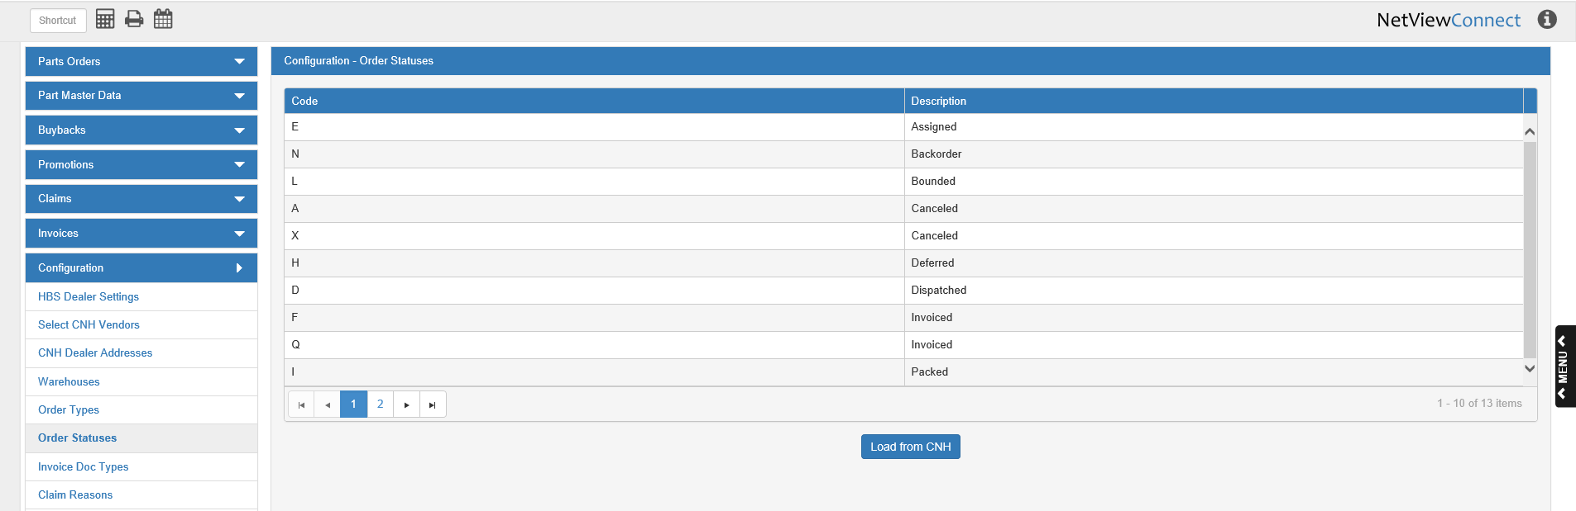

**Code:** This column holds the CNH Order Status Code.

**Description:** This column describes the actual status that the code stands for. For example, as seen in the above image, Code “N” means that the ordered parts are currently on backorder.

**Load from CNH:** When you first open CNH Connect (CSPS), you will need to click this button to load the Order Statuses from CNH, or you will not be able to see the status codes applied to your orders. After the first use of the button, the program will automatically reload the list every 30 days, although you can still click the button at any point in time to load the most updated version of the list.